Easy:

1. Question 1



Choices:

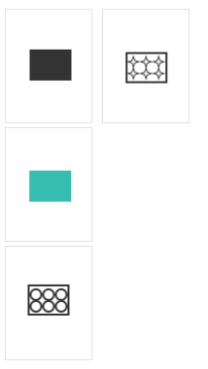

Correct Answer



1. Question 2:

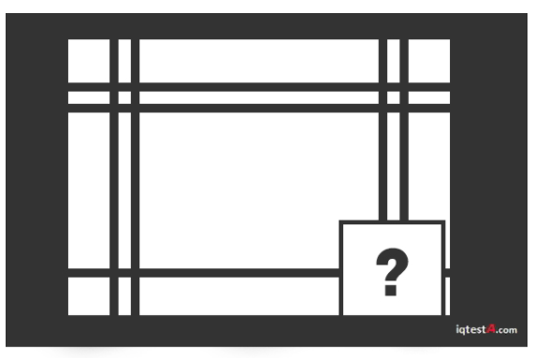

Choices:

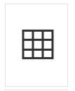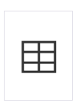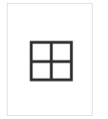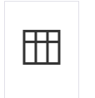

Correct Answer:

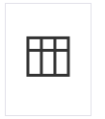

1. Question 3:

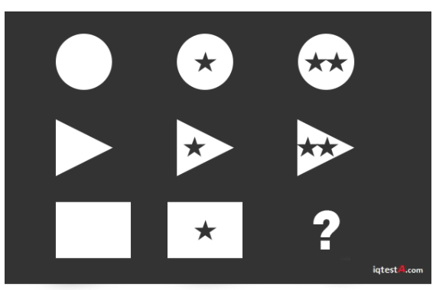

Choices:

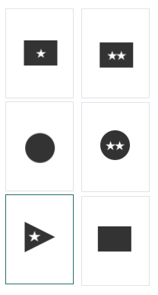

Correct Answer:



1. Question 4

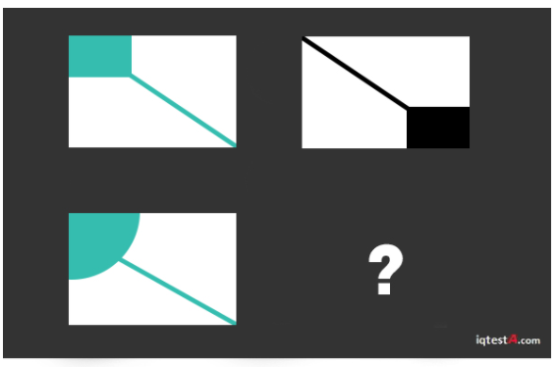

Choices:

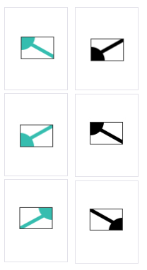

Correct Answer:

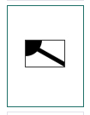

1. Question 5



Choices:

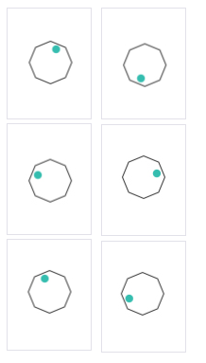

Correct Answer:

1. Question 6

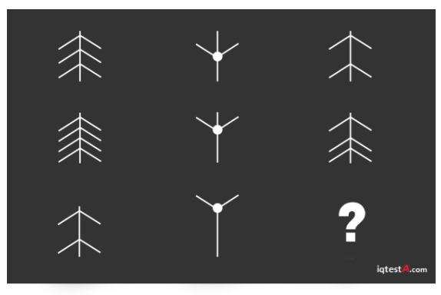

Choices:

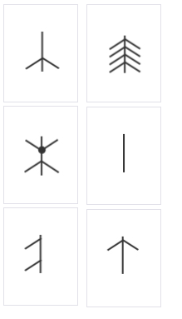

Correct Answer:

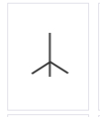

1. Question 7

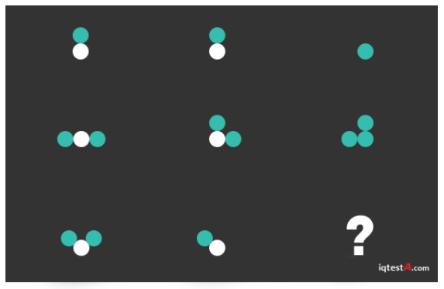

Choices:

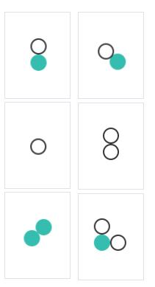

Correct Answer:

1. Question 8

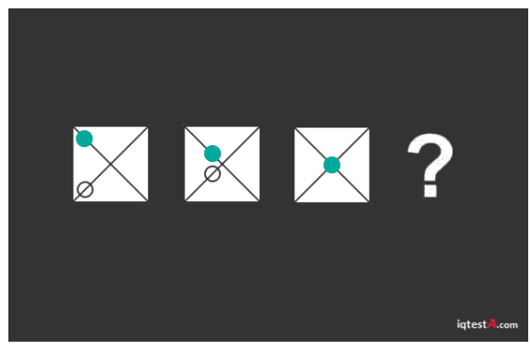

Choices:

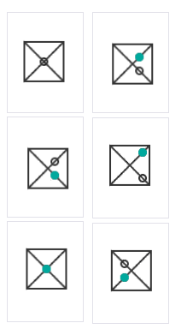

Correct Answer:



1. Question 9



Choices:

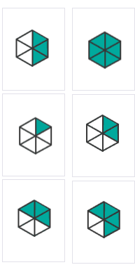

Correct Answer:



1. Question 10

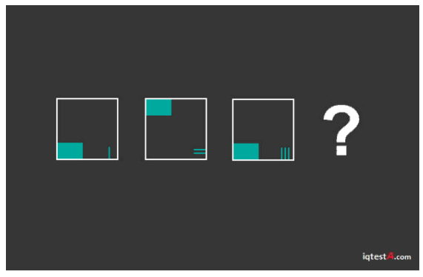

Choices:

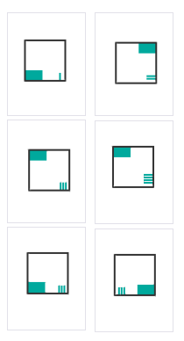

Correct Answer:



1. Question 11

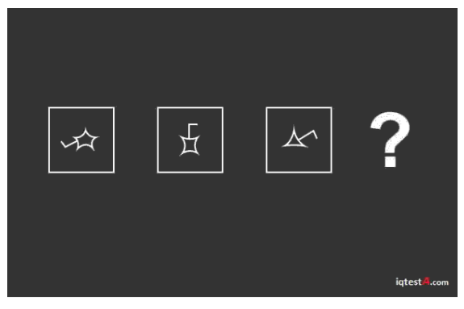

Choices:

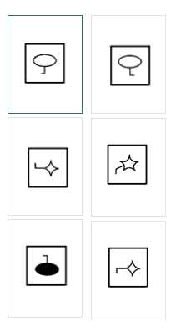

Correct Answer:

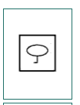

1. Question 12

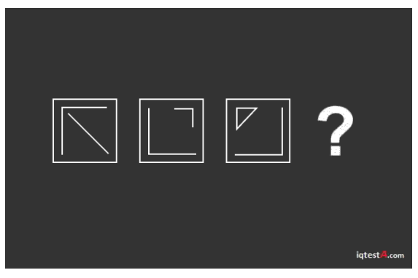

Choices:

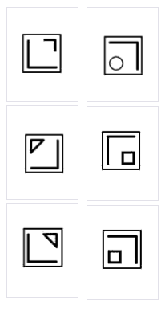

Correct Answer:

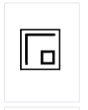

1. Question 13

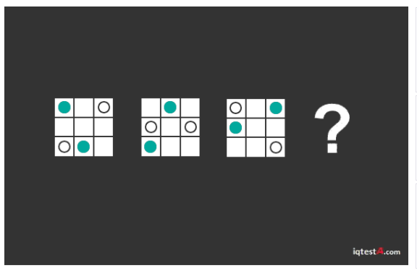

Choices:

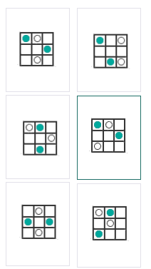

Correct Answer:

1. Which one of the five is least like the other four?

Choices:

1) Dog, 2) Mouse, 3) Lion 4) Snake 5) Elephant

Correct Answer:

4)

1. 2. Which number should come next in the series?

Choices:

* 8
* 13
* 21
* 26
* 31

Correct Answer:

21

1. Which one of the five choices makes the best comparison?

Choices:

* 25641
* 26451
* 12654
* 51462
* 15264

Correct Answer:

15264

1. Mary, who is sixteen years old, is four times as old as her brother. How old will Mary be when she is twice as old as her brother?

Choices:

* 20
* 24
* 25
* 26
* 28

Correct Answer:

24

1. Which larger shape would be made if the two sections are fitted together?

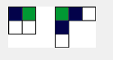

Choices:

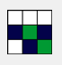

Correct Answer:



1. Which one of the numbers does not belong in the following series?

2 - 3 - 6 - 7 - 8 - 14 - 15 - 30

Choices:

* THREE
* SEVEN
* EIGHT
* FIFTEEN
* THIRTY

Correct Answer:

* EIGHT

1. Which one of the five choices makes the best comparison?

Finger is to Hand as Leaf is to:

Choices:

* Twig
* Tree
* Branch
* Blossom
* Bark

Correct Answer:

1. If you rearrange the letters "CIFAIPC" you would have the name of a(n):

Choices:

* City
* Animal
* Ocean
* River
* Country

Correct Answer:

* Ocean

1. Choose the number that is 1/4 of 1/2 of 1/5 of 200:

Choices:

* 2
* 5
* 10
* 25
* 50

Correct Answer:

5

1. John needs 13 bottles of water from the store. John can only carry 3 at a time. What's the minimum number of trips John needs to make to the store?

Choices:

* 3
* 4
* 4 1/2
* 5
* 6

Correct Answer:

5

1. If all Bloops are Razzies and all Razzies are Lazzies, all Bloops are definitely Lazzies.

Choices:

* True
* False

Correct Answer:

True

1. Choose the word most similar to "Trustworthy":

Choices:

* Resolute
* Tenacity
* Relevant
* Insolent
* Reliable

Correct Answer:

* Reliable

1. If you rearrange the letters "LNGEDNA" you have the name of a(n):

Choices:

* Animal
* Country
* State
* City
* Ocean

Correct Answer:

* Country

1. Which one of the numbers does not belong in the following series?

1 - 2 - 5 - 10 - 13 - 26 - 29 - 48

Choices:

* 1
* 5
* 26
* 29
* 48

Correct Answer:

48

1. Ralph likes 25 but not 24; he likes 400 but not 300; he likes 144 but not 145. Which does he like:

Choices:

* 10
* 50
* 124
* 200
* 1600

Correct Answer:

1600

1. How many four-sided figures appear in the diagram below?

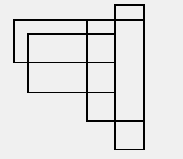

Choices:

* 10
* 16
* 22
* 25
* 28

Correct Answer:

25

1. What is the missing number in the sequence shown below?

1 - 8 - 27 - ? - 125 - 216

Choices:

* 36
* 45
* 46
* 64
* 99

Correct Answer:

64

1. Which one of the following things is the least like the others?

Choices:

* Poem
* Novel
* Painting
* Statue
* Flower

Correct Answer:

Flower

1. Which of the figures below the line of drawings best completes the series?



Choices:



Correct Answer:



1. Which of the figures below the line of drawings best completes the series?



Choices:

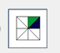

Correct Answer:



1. To fill a tank, 25 buckets of water is required. How many buckets of water will be required to fill the same tank if the capacity of the bucket is reduced to two-fifth of its present?

Difficulty: Medium

Choices:

* 10
* 35.25
* 50.15
* 62.5
* 70

Correct Answer:

62.5

1. Tina gets married to Tony next month. One year ago from the date Tina will get married, Tony was away in Rome for New Year's Eve. What month is it?

Difficulty: Medium

* November
* December
* January
* February
* March

Correct Answer:

November

1. In the stack of cubes below, the green number on the top of each column of cubes represents the positive value assigned to each cube in the column whereas the red number on the sides represents the negative value assigned to each cube in the row. To get the total value of a cube you subtract the negative value from the positive. So, the top cube would be 4 - 2 = 2. The total value of the stack of cubes is 17. What is the missing value?

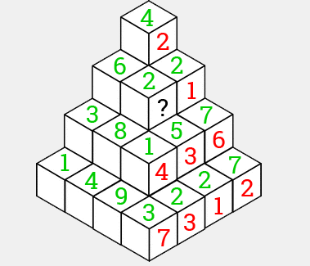

Choices:

1, 2, 3, 4,5

Correct Answer

5

1. A 250 meter long train, travelling at 75 km/h, enters a tunnel of three and a half kilometers in length. How much time will elapse between the moment the front of the train enters the tunnel and the moment the end of the train leaves the tunnel?

Choices:

* 2 mins 48 secs
* 3 mins
* 3 mins 15 secs
* 3 mins 25 secs
* 4 mins

Correct Answer

3mins

1. What number should replace the question mark in the diagram below?

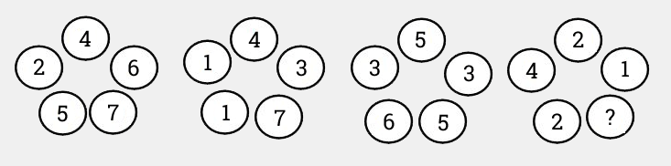

Difficulty: Medium

Choices:

* 3
* 4
* 5
* 6
* 7

Correct Answer:

5

In each group of circles, the top three numbers total the same as the bottom two numbers.

1. A truck has traveled 90 km at 120 km/hr. It started its trip with 20 gallons of fuel but its tank has been leaking throughout the journey and is now empty. The truck travels 30 km per gallon. How many gallons of fuel does the truck leak per hour?

Choices:

* 3 per hour
* 17 per hour
* 13.33 per hour
* 22.67 per hour
* 25 per hour

Correct Answer:

22.67

The car has been travelling for 90km / 120 km/hr = .75 hrs = 45 minutes.

The car has used 90km / 30km/gallon = 3 gallons of gas.

17 gallons of gas have leaked in 45 minues, so the car leaks 17 gallons x (60mins/45mins) = 22.67 gallons per hour.

1. What number comes next in the following sequence?

2 3 10 15 26 35 50 63 82 ?

Choices:

* 97
* 99
* 101
* 103
* 105

Correct Answer:

99

Square numbers that alternate between plus and minus one.

12 + 1 = 2.

22 - 1 = 3.

32 + 1 = 10.

Etc…

1. If you have to calculate the numbers below in the order shown, without changing the order of the numbers and you have to replace each question mark with a mathematical sign (plus, minus, multiply and divide) and each can be used once only, what is the highest number you can possibly calculate?

Choices:

* 13.33
* 13.5
* 20
* 26.5
* 33

Correct Answer:

26.5

Divide, Add, Multiply, Subtract.

7 / 4 = 1.75 + 3 = 4.75 x 6 = 28.5 - 2 = 26.5

1. Monica likes Mexico, Samuel likes Serbia, Ingrid likes Iran and Randy likes Russia. Who likes Malta?

Choices:

* Marcel
* Molly
* Melvin
* Milton
* Michael

Correct Answer:

Marcel

The first and second letters of the name are the first and last letters of the country.

1. Throughout the baseball season the Cubs were averaging 3.2 runs per game for the first 45 games. After another 30 games the number of runs they were averaging decreased to 3 runs per game. How many runs did the Cubs average over the last 30 games?

Choices:

* 2.5
* 2.7
* 2.9
* 3
* 3.2

Correct Answer:

2.7

The Cubs scored 3.2 runs x 45 games = 144 runs over the first 45 games.

After another 30 games they had scored a total of (45 games + 30 games) x 3 runs = 225 runs.

Over the last 30 games they must have averaged (225 runs - 144 runs) / 30 games = 2.7 runs.

1. Which of the following numbers below does not belong?

3146 5412 3454 4256 6116

Difficult: Medium

Choices:

* 3146
* 5412
* 3454
* 4256
* 6116

Correct Answer:

4256

In all of the numbers except 4256, the first digit minus the second digit plus the third digit equals the fourth digit.

1. Adding three of the numbers below, how many different combinations of 33 can you get if each number can be used more than once?

3 5 10 15 20 25

Difficulty: Medium

Choices:

* 1
* 2
* 3
* 4
* 5

Correct Answer:

3

15 + 15 + 3

25 + 5 + 3

20 + 10 + 3

1. Which number does NOT belong in the series below?

53, 59, 61, 63, 67, 71, 73, 79

Difficulty: Very Hard

Choices:

* 61
* 63
* 67
* 71
* 73

Correct Answer:

63

This is a series of prime numbers starting at 53 and ending at 79. 63 is not a prime number.

1. Tickets numbered 72 to 91 are mixed up and then a ticket is drawn at random. What is the probability that the ticket drawn has a number which is a multiple of 3 or 7?

Difficult: Hard

Choices:

* 35%
* 40%
* 45%
* 50%
* 55%

Correct Answer:

45%

There are 20 tickets total. 9 tickets (72, 75, 77, 78, 81, 84, 87, 90, 91) are multiples of either 3 or 7.

9/20 = 45%

1. A woman pointed to a man in a photograph, and said, "His brother's father is the only son of my grandfather." How is the woman related to the man in the photograph?

Difficulty: Medium

Choices:

* His sister
* His aunt
* His daughter
* His grandmother
* His mother

Correct Answer:

His Sister

The only son of her grandfather is her father.

The man's brother's father is of course also his father.

If they both share the same father that makes the man she is pointing at her brother.

1. Which number is missing from the following series?

1, 4, 27, 16, ?, 36, 343

Choices:

* 25
* 50
* 64
* 125
* 132

Correct Answer:

125

The series consists of cubes of odd numbers and square of even numbers.

1. Pointing to a photograph, a man said, "I have no brother or sister but that man’s father is my father’s son." Who was he pointing at in the photograph?

Difficulty: Hard

Choices:

* His Brother
* His Own
* His Father
* His Son
* No relation

Correct Answer:

His Son

1. If two dice are thrown at the same time, what is the probability of rolling two numbers whose product is even?

Difficulty: Very Hard

Choices:

* 1/4
* 1/2
* 2/3
* 3/4
* 7/8

Correct Answer:

¾

In a simultaneous throw of two dice there are 6 x 6 = 36 possible outcomes.

Of those 36 possible outcomes, 27 have two numbers whose product is an even number. 27 / 36 = 3 / 4

{(1, 2), (1, 4), (1, 6), (2, 1), (2, 2), (2, 3), (2, 4), (2, 5), (2, 6), (3, 2), (3, 4), (3, 6), (4, 1), (4, 2), (4, 3), (4, 4), (4, 5), (4, 6), (5, 2), (5, 4), (5, 6), (6, 1), (6, 2), (6, 3), (6, 4), (6, 5), (6, 6)}

1. A man travels down the road on his motorcycle and goes the first 160 km at 64 km/hr, then the next 160 km at 80 km/hr. The average speed for the first 320 km he travels is:

Difficulty: Hard

Choices:

* 36 km/hr
* 68.25 km/hr
* 70 km/hr
* 71.11 km/hr
* 72 km/hr

Correct Answer:

The total time taken for the 320 km is 160/64 + 160/80 = 9/2 = 4.5 hours.

320 km / 4.5 hrs = 71.11 km/hr

1. Which group of letters best completes the sequence below?

OTE, PUF, QVG, RWH, ?

Difficulty: Easy

Choices:

* SXI
* SYJ
* TCI
* SXJ
* RXI

Correct Answer:

SXI

1. 12 men can complete some work in 18 days. Six days after they started working, 4 more men joined them. How many days will all of them be working together to complete the remaining work?

Difficulty: Hard

Choices:

* 8
* 9
* 10
* 11
* 12

Correct Answer:

9

1. Which letter best completes the sequence below?

M, N, O, L, R, I, V, ?

Choices:

* A
* E
* F
* H
* L

Correct Answer:

E

The series consists of two groups (M, O, R, V) and (N, L, I, ?). The letters in the first group move 2, 3, 4, ... steps forward. The letters in the second group move 2, 3, 4...steps backward.

1. In the boxes below, the sum of each two adjacent blocks gives the number for the block above. What number should replace the question mark?

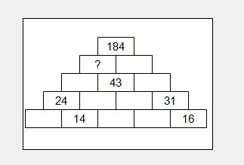

Difficulty: Medium

Choices:

* 41
* 52
* 72
* 88
* 96

Correct Answer:

88

1. At a meeting for exotic animal eaters, 12 attendees all shook hands with each other before the roasted parrot was served. How many total number of hand shakes occurred?

Choices:

* 12
* 60
* 66
* 67
* 144

Correct Answer:

66

The first person shook hands with 11 remaining people, the second person also shook hands with 11 people, but we count 10, as the hand shake with the first person has already been counted. Then add 9 for the third person, 8 for the fourth one & proceeding in this fashion we get: 11 + 10 + 9 + 8 + 7 + 6 + 5 + 4 + 3 + 2 + 1 = 66.

1. The Pi Kappa Alpha fraternity brothers have a tub filled with, 5 parts water and 3 parts jello. This is too watery for jello wrestling. How much of the mixture must be drawn off and replaced with jello so that the mixture may be half water and half jello?

Choices:

* 1/3
* 1/4
* 1/5
* 1/6
* 1/7

Correct Answer:

1/5

1. In how many different ways can the letters of the word 'LEADING' be arranged in such a way that the vowels always come together?

Choices: 5, 121, 169, 343, 720

Correct Answer: 720

The word 'LEADING' has 7 different letters. When the vowels EAI are always together, they can be treated as one letter. Then, we have to arrange the letters LNDG (EAI).

Now, 5 (4 + 1 = 5) letters can be arranged in 5! = 120 ways.

The vowels (EAI) can be arranged among themselves in 3! = 6 ways.

Required number of ways = (120 x 6) = 720.

1. In a 100m dash, Ryan can give Brian a 10 meter head start and he can give Leah a 28 meter head start and still cross the line first. In the same distance, Brian can give Leah how much of a head start and still win?

Choices:

* 20 meters
* 18 meters
* 15 meters
* 12 meters
* 10 meters

Correct Answer:

20 meters

From the information above, we know that Brian can run 90 meters in the same amount of time Ryan can run 100 and that Leah can run 72 meters in that same amount of time. So, when Brian runs 90 meters, Leah runs 72 meters. When he runs 100 meters, Leah runs 72/90 x 100 meters = 80 meters.

1. Andy fires 5 shots to Brian's 3 but Andy hits only once in 3 shots while Brian hits once in 2 shots. When Brian has missed 27 times, Andy has hit:

Choices:

* 10
* 20
* 30
* 60
* 72

Correct Answer:

30

1. A motorboat, whose speed in 15 km/hr in still water goes 30 km downstream and comes back in a total of 4 hours 30 minutes. The speed of the stream (in km/hr) is:

Choices:

* 2 km/hr
* 3.25 km/hr
* 4 km/hr
* 4.5 km/hr
* 5 km/hr

Correct Answer:

5km/hr

1. Which number should come next in the series below?

8, 6, 9, 23, 87, ?

Choices:

* 128
* 226
* 324
* 429
* 533

Correct Answer:

429

8 x 1 - 2 = 6

6 x 2 - 3 = 9

9 x 3 - 4 = 23

23 x 4 - 5 = 87

87 x 5 - 6 = 429

1. Statements: Some doctors are fools. Some fools are rich.

Conclusions: 1) Some doctors are rich. 2) Some rich are doctors.

Choices:

* Only conclusion 1 follows
* Only conclusion 2 follows
* Neither 1 or 2 follows
* Both 1 and 2 follows

Correct Answer:

Neither 1 or 2 follows

Since both the premises are particular, no definite conclusion follows.

1. Which letter should go in place of the question mark in the image below?

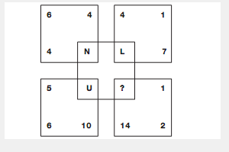

Choices:

* B
* I
* J
* L
* Q

Correct Answer:

Q

Adding the three numbers in each square together gives the numerical value (a = 1, b = 2 etc...) of the letter in each square.

1. Which letter replaces the question mark?

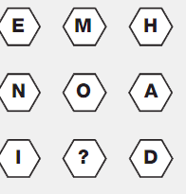

Choices:

* A
* B
* C
* J
* M

Correct Answer:

M

Working in rows, add together the numerical values of the left and right hand letters to give the numerical value of the central letter.

1. Find the missing number in the drawing below.

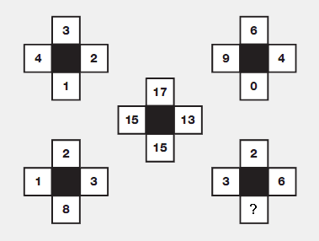

Choices:

* 0
* 2
* 5
* 6
* 11

Correct Answer:

6

Take values in corresponding positions of the outer 4 shapes, and put the results in the central shape, rotating the position of this result by 1/4 turn each time.

1. What number best completes the table below?

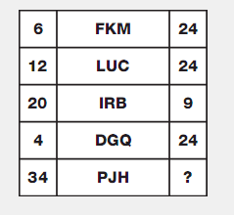

Choices:

* 0
* 1
* 5
* 12
* 24

Correct Answer:

0

In each row, the left hand number equals the total of the even valued letters (b = 2, d = 4, etc...) in the middle box, and the right hand number equals the total of the odd valued letters in the middle box.

1. Find the number of triangles in the given figure.

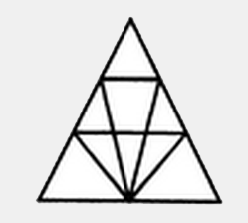

Choices:

* 12
* 16
* 18
* 22
* 24

Correct Answer:

18

1. What is the missing card in the diagram below?

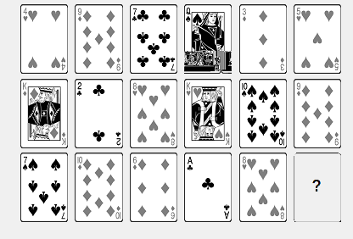

Correct Answer:

* 2 of any suit
* 4 of any suit
* 7 of any suit
* 10 of any suit
* K of any suit

Correct Answer:

7 of any suit

Using the value of Aces as 1 and all face cards as 10

In each column of the diagram, the value of the sum of the 3 cards is always 21.

1. Find the missing letter in the image below.

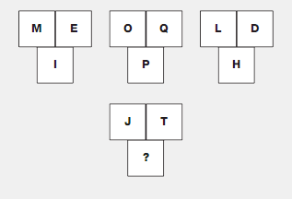

Choices:

* A
* C
* D
* L
* O

Correct Answer:

O

In each group of 3 boxes, the numerical value in the lower box equals the average of the numerical values of the letters in the top 2 boxes.

1. Where should the minute hand be put on the bottom clock?

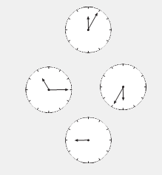

Choices:

* Pointing to 5
* Pointing to 6
* Pointing to 9
* Pointing to 12
* Pointing to 1

Correct Answer:

Pointing to 5

Starting with the top clock and moving counterclockwise around the others, the hour hand moves back 1 hour, then 2, then 3 etc, while the minute hand moves forward 10 minutes each time.

1. Find the missing number in the table below.

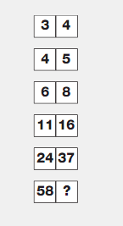

Choices:

* 85
* 86
* 92
* 95
* 101

Correct Answer:

92

Working from top to bottom, left to right, add together the first two numbers and subtract 3 to give the next value along.

1. Choose correct picture

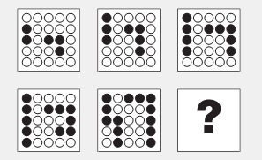

Choices:

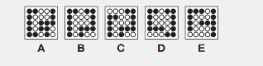

Correct Answer:

A

1. Six bells commence tolling together, then, toll at intervals of 2, 4, 6, 8 10 and 12 seconds respectively. In 30 minutes, how many times do they toll together?

Choices:

* 4
* 8
* 10
* 15
* 16

Correct Answer:

16

The lowest common multiple of 2, 4, 6, 8, 10, 12 is 120.

So, the bells will toll together after every 120 seconds = 2 minutes.

In 30 minutes, they will toll together 30 / 2 = 15 times + 1 (the first toll) = 16 times.

1. Complete the pattern below.



Choices:

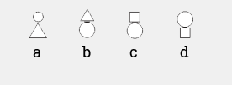

Correct Answer:

C

All four segments use the same figures: two squares, one circle, and one triangle. In the first segment, the squares are on the outside of the circle and triangle. In the second segment, the squares are below the other two. In the third segment, the squares on are the inside. In the fourth segment, the squares are above the triangle and circle.

1. Find the minimum number of straight lines required to make the given figure.

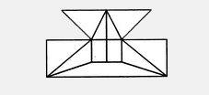

Choices:

* 14
* 15
* 16
* 17
* 18

Correct Answer:

17

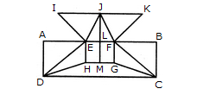

The horizontal lines are IK, AB, HG and DC i.e. 4 in number.

The vertical lines are AD, EH, JM, FG and BC i.e. 5 in number.

The slanting lines are IE, JE, JF, KF, DE, DH, FC and GC i.e. 8 is number.

Thus, there are 4 + 5 + 8 = 17 straight lines in the figure.

1. How many 3-digit numbers can be formed from the digits 2, 3, 5, 6, 7 and 9, which are divisible by 5 and none of the digits is repeated?

Choices:

* 5
* 10
* 15
* 20
* 25

Correct Answer:

20

Since each desired number is divisible by 5, so we must have 5 at the unit place. So, there is 1 way of doing it.

The tens place can now be filled by any of the remaining 5 digits (2, 3, 6, 7, 9). So, there are 5 ways of filling the tens place.

The hundreds place can now be filled by any of the remaining 4 digits. So, there are 4 ways of filling it.

Required number of numbers = (1 x 5 x 4) = 20.

1. Find the missing number in the image below.

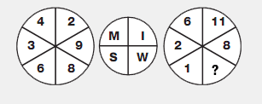

Choices:

* 2
* 4
* 5
* 7
* 10

Correct Answer:

4

Split the left and right hand circles into 2 halves vertically. The numerical value of the letter in the upper left segment of the central circle equals the sum of the numbers in the left half of the left hand circle, and the letter in the lower left equals the sum of the numbers in the right half of the left hand circle. Repeat this pattern for the right hand circle.

1. Find the number of triangles in the figure below.



Choices:

* 21
* 23
* 25
* 27
* 28

Correct Answer:

27

The simplest triangles are GLK, DLJ, DJM, HMN, QRE, IRA, IPA and FPO i.e. 8 in number.

The triangles having two components each are BDO, CDQ, DLM, PRA, KFI, NEI, HJI, GJI, DKI and DNI i.e. 10 in number.

The triangles having four components each are DIE, DFI, DOA, DQA andGHI i.e. 5 in number.

The triangles having six components each are DCA and DBA i.e. 2 in number.

DEF is the only triangle having eight components.

ABC is the only triangle having twelve components.

Thus, there are 8+10+ 5 + 2+1 + 1 = 27 triangles in the figure.

1. What number comes next in the series below?

8, 6, 9, 23, 87, ?

Choices:

* 128
* 226
* 324
* 361
* 429

Correct Answer:

429

8 x 1 - 2 = 6

6 x 2 - 3 = 9

9 x 3 - 4 = 23

23 x 4 - 5 = 87

87 x 5 - 6 = 429

1. What is the minimum number of colors required to fill the spaces in the given diagram without any two adjacent spaces having the same color?

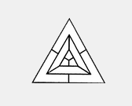

Choices:

* 3
* 4
* 5
* 6
* 7

Correct Answer:

3

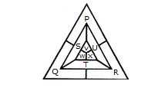

The spaces P, Q and R have to be shaded by three different colors definitely (since each of these three spaces lies adjacent to the other two).

Now, in order that no two adjacent spaces be shaded by the same color, the spaces T, U and S must be shaded with the colors of the spaces P, Q and R respectively.

Also the spaces X, V and W must be shaded with the colors of the spaces S, T and U respectively i.e. with the colors of the spaces R, P and Q respectively. Thus, minimum three colors are required.

1. An error of 2% in excess is made while measuring the side of a square. The percentage of error in the calculated area of the square is:

Choices:

* 2%
* 2.02%
* 4%
* 4.04%
* 4.14%

Correct Answer:

4.04%

100 cm is read as 102 cm.

A1 = (100 x 100) cm2 and A2 (102 x 102) cm2.

(A2 - A1) = [(102)2 - (100)2] = (102 + 100) x (102 - 100) = 404 cm2.

Percentage error = 404 / (100 x 100) \* 100 = 4.04%

1. Select the figure which could satisfy the same conditions of placement of the dots as in Figure-X.

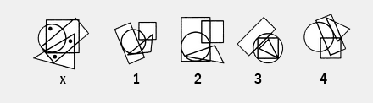

Choices:

* 1
* 2
* 3
* 4

Correct Answer:

4

In fig. (X), one of the dots lies in the region common to the circle and the square only, another dot lies in the region common to the square, the triangle and the rectangle only and the third dot lies in the region common to the triangle and the rectangle only. In each of the figures (1), (2) and (3) there is no region common to the square, the triangle and the rectangle only. Only fig. (4) consists of all the three types of regions.

1. Find the missing number in the diagram below.

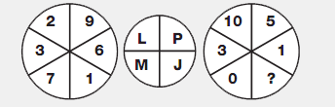

Choices:

* 2
* 3
* 4
* 6
* 8

Correct Answer:

4

Split the left and right hand circles in half vertically. The letter with the numerical value of the sum of the digits in the left half of the left hand circle is placed in the top left segment of the central circle, and the letter with the numerical value of the sum of the digits in the right half of the left hand circle is placed in the top right segment of the central circle. Repeat this formula for the 2 halves of the right hand circle, putting the resulting letters in the lower segments of the central circle.

1. Where should the missing hour hand point in the figure below?

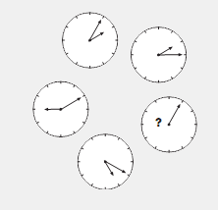

Choices:

* 2
* 4
* 5
* 6
* 9

Correct Answer:

6

Starting with the top left clock face and working clockwise around the others, the sum of the numbers pointed to by the 2 hands starts at 3 and increases by 2 each time.

1. Find the number of triangles in the given figure



Choices:

21, 23, 25, 27, 28

Correct Answer:

27

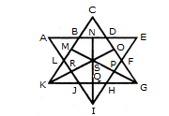

The simplest triangles are ABL, BCD, DEF, FGP, PGH, QHI, JQI, KRJ and LRK i.e. 9 in number.

The triangles composed of two components each are OSG, SGQ, SPI, SRI, KSQ, KMS, FGH, JHI and JKL i.e. 9 in number.

There is only one triangle i.e. KSG which is composed of four components.

The triangles composed of five components each are NEI, ANI, MCG and KCO i.e. 4 in number.

The triangles composed of six components each are GMK and KOG i.e. 2 in number.

There is only one triangle i.e. AEI composed of ten components.

There is only one triangle i.e. KCG composed of eleven components.

Therefore, Total number of triangles in the given figure = 9 + 9+1 + 4 + 2+1 + 1 = 27.

1. Find the missing letter in the diagram below.

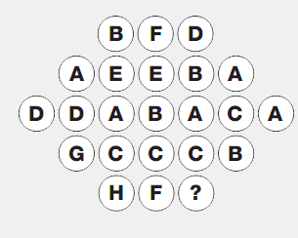

Choices:

* A
* B
* C
* D
* F

Correct Answer:

F

Working in rows, from top to bottom, the sum of the numerical values of the letters in each row starts at 12, and increases by 2 as you go down each row.

1. Find the number of triangles in the given figure.



Choices:

* 5
* 6
* 7
* 8
* 10

Correct Answer:

10

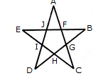

The simplest triangles are AJF, FBG, GCH, HDI and IEJ i.e. 5 in number.

The triangles composed of three components each EBH, AIC, EFC, ADG and BJD i.e. 5 in number.

Thus, there are 5 + 5 = 10 triangles in the figure.

1. Replace the question mark in the diagram below with the correct numbe

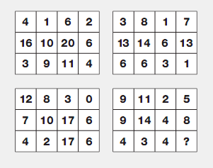

Choices:

* 3
* 6
* 8
* 11
* 13

Correct Answer:

8

In each grid, working in columns, add the top and bottom numbers together, and put this sum in the center square in the grid underneath the original (for the top grids), or the grid above (for the lower grids).

1. Find the number of quadrilaterals in the given figure below

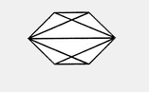

Choices:

* 6
* 7
* 9
* 11
* 12

Correct Answer:

11

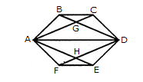

The quadrilaterals in the figure are ABCD, ABDE, ABDF, ABDH, CDHA, CDEA, CDFA, DEAG, DEFA, FAGD and AGDH.

The number of quadrilaterals in the figure is 11.

1. There are six persons A, B, C, D , E and F. C is the sister of F. B is the brother of E's husband. D is the father of A and grandfather of F. There are two fathers, three brothers and a mother in the group. Which of the following is a group of brothers?

Choices:

* ABD
* ABF
* ADF
* BFC
* BDF

Correct Answer:

ABF

D is father of A and grandfather of F. So, A is father of F.

Thus, D and A are the two fathers.

C is the sister of F. So, C is the daughter of A.

Since there is only one mother, it is evident that E is the wife of A and hence the mother of C and C and F.

So, B is brother of A.

There are three brothers. So, F is the brother of C.

Hence, B and A are brothers.

F is the brother of C. So, three brothers are A, B, F.

1. In a race of 200m, A can beat B by 31m and C by 18m. In a race of 350m, C will beat B by:

Choices:

* 22m
* 22.75m
* 25m
* 27m
* 28.25m

Correct Answer:

25m

A: B = 200: 169.

A: C = 200: 182.

C/B = (C/A x A/B) = (182/200 x 200/169) = 182: 169

When C covers 182m, B covers 169m.

When C covers 350 m, B covers (169/182 x 350) = 325m

Therefore, C beats B by (350 - 325) m = 25m.

1. It is being given that (232 + 1) is completely divisible by a whole number. Which of the following numbers is completely divisible by this number?

Choices:

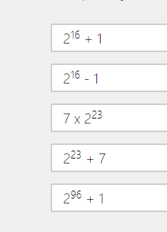

Correct Answer:

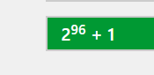

Let 232 = x. Then, (232 + 1) = (x + 1).

Let (x + 1) be completely divisible by the natural number N. Then,

(296 + 1) = [(232)3 + 1] = (x3 + 1) = (x + 1)(x2 - x + 1), which is completely divisible by N, since (x + 1) is divisible by N.

1. Find the missing letter in the diagram below.

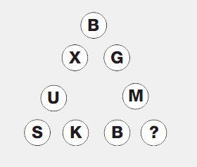

Choices:

* T
* U
* V
* W
* Y

Correct Answer:

T

Starting in the bottom left corner of the diagram, and moving clockwise, letters follow in alphabetic order, skipping 1 letter, then 2, then 3 etc.

1. Complete the series below.

M, N, O, L, R, I, V, ?

Choices:

* A
* E
* F
* H
* I

Correct Answer:

E

The series consists of two groups (M, O, R, V) and (N, L, I?). The letters in the first group move 2, 3, 4, ... steps forward. The letters in the second group move 2, 3, 4, ... steps backward.

1. Where should the hour hand be pointing on the bottom clock?

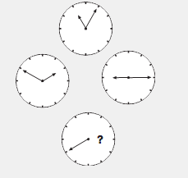

Choices:

* 4
* 5
* 6
* 9
* 10

1. There is a man hung from the ceiling of an empty room. It is windowless room with no doors, tables, chairs...nothing. A puddle of water is on the floor beneath him. How did he manage to hang himself?

Answer:

He used a block of ice to reach the rope he used to hang himself and the ice eventually melted.

1. A man and his son get in a terrible automobile accident and are rushed to the nearest emergency room where they are rushed into surgery. The attending physician looks at the boy, stops and says, "I can't operate on this boy, he's my son!" How is this possible?

Answer: The doctor is the boy's mother.

1. A man leaves home one evening, makes 3 left turns and returns home to find two masked men waiting for him. Unfortunately, he's arrived back home later than he intended. One of the men in the masks tells him something that makes him upset. What is it that he told him?

Answer:

"You're out!" The man is of course a baseball player and he has rounded the bases (3 left turns) but...not quickly enough to beat the tag by the catcher (one of the men in a mask). This of course provokes the umpire (the second masked man) to break the news.